Exercise 1 – Control Structures and Stored Procedures

Scenario 1 – Apply Discount to Loan Interest Rates
- Create a procedure to reduce the interest rate by 1% for customers above a certain age (or as specified in the exercise).
- Verify the updated loan records.
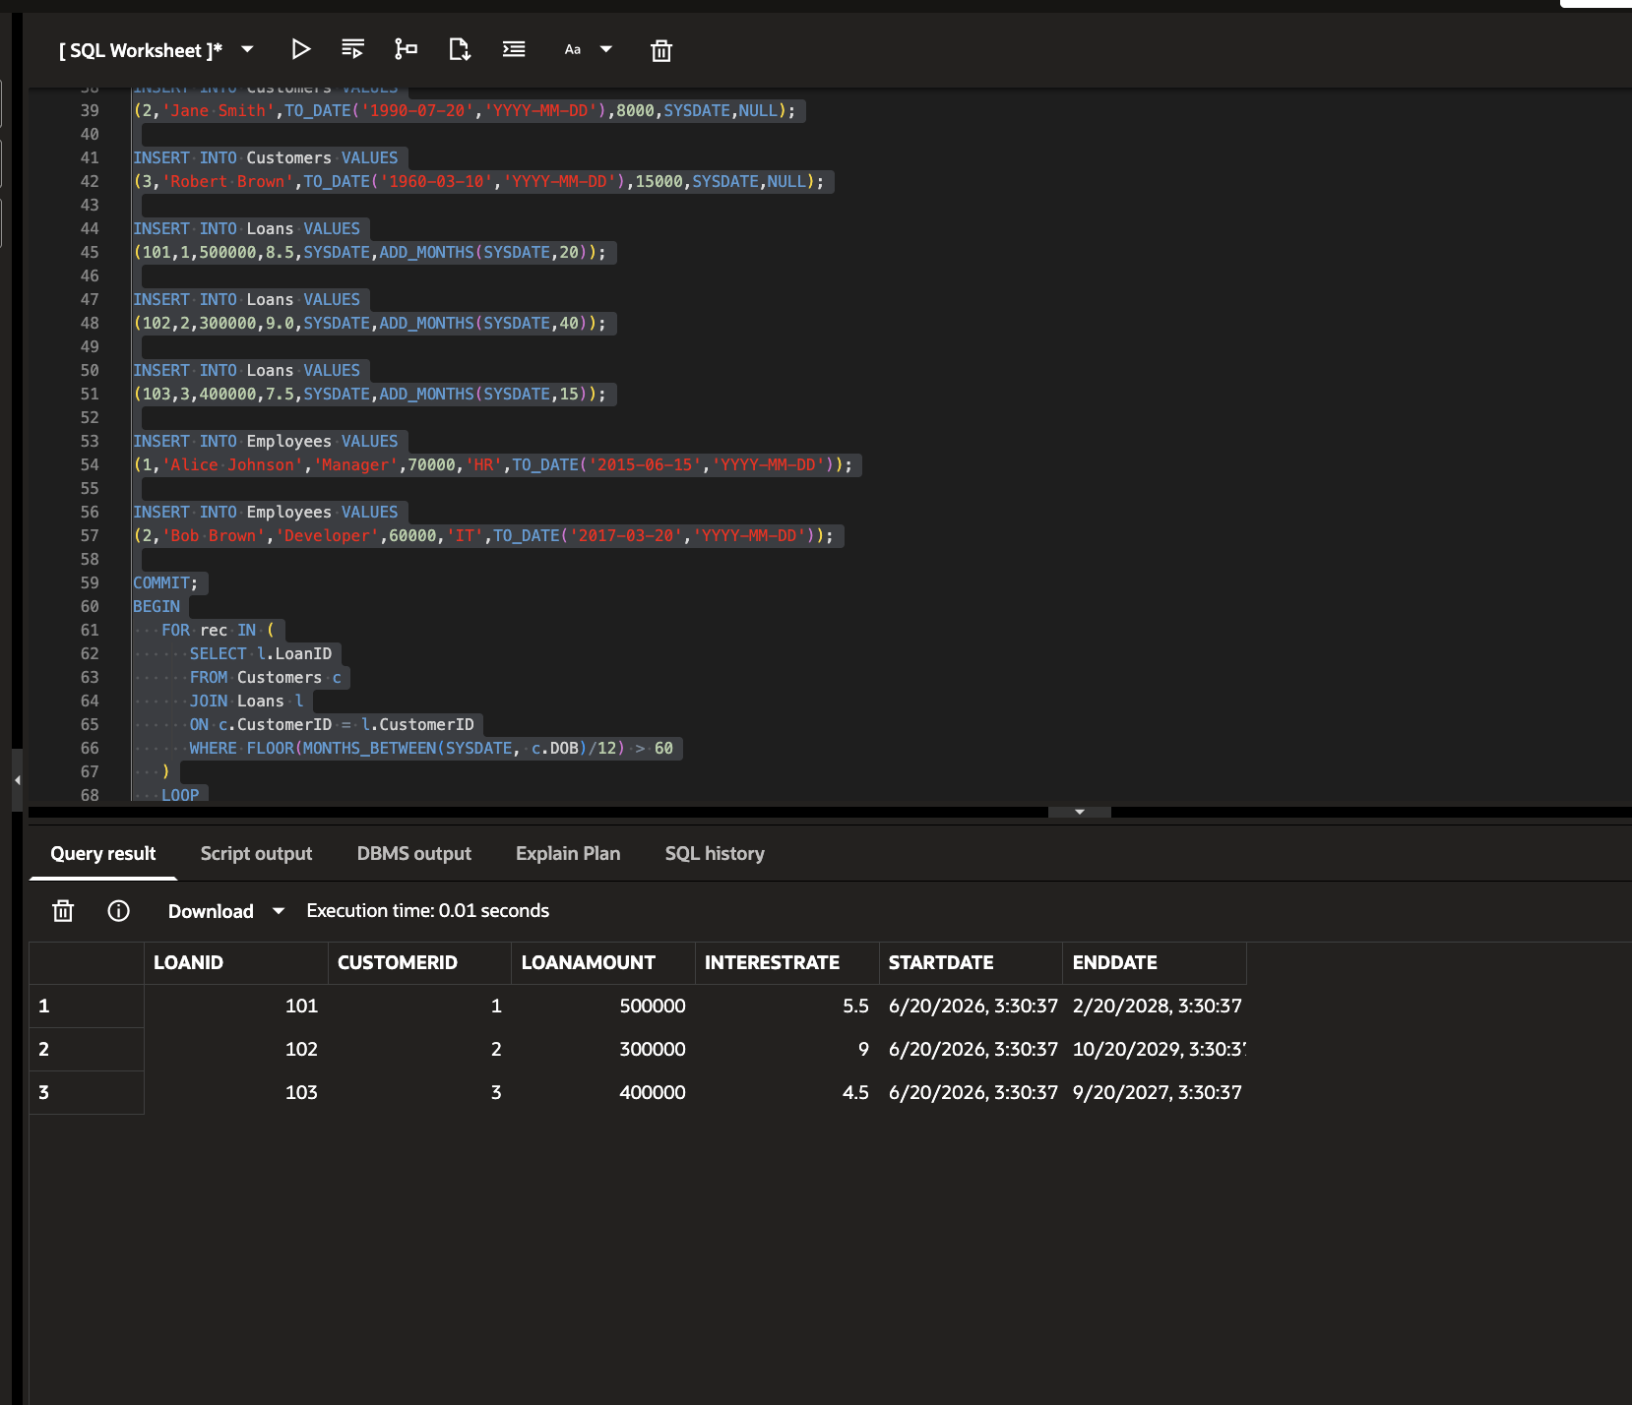

Scenario 2 – Promote Customers to VIP
- Create a procedure that checks customer balances.
- If the balance is above the given limit (e.g., ₹10,000), update the customer's status to VIP.
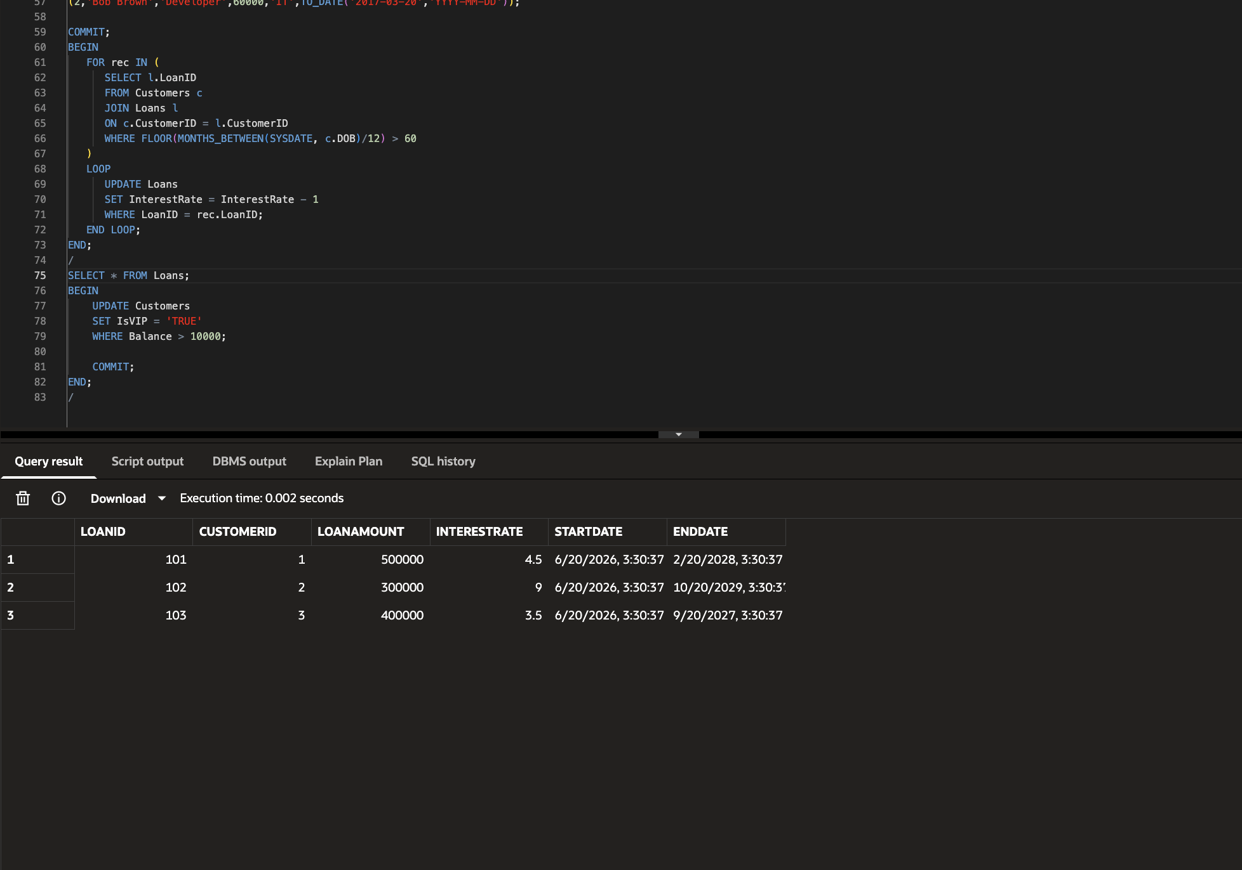

Scenario 3 – Send Loan Due Reminders
- Create a procedure that finds loans due within the specified number of days (e.g., 30 days).
- Display or generate reminders for those customers.

